Introducing our ICS Coaching & Mentoring Hub!
We are delighted to introduce to you our Coaching and Mentoring Hub for Herefordshire and Worcestershire Integrated Care System (ICS) - providing access to expert coaching for colleagues from any organisation or sector in our ICS.
What is coaching?
“A transformative journey where you discover your true potential with a trusted navigator” International Coaching Federation

Coaching is a powerful conversation-based development tool which is designed to enable you to make a change, find solutions and unlock your potential. This is achieved working with a qualified coach and through the use of expert listening, questioning & feedback skills, as well as a range of specialist coaching tools, models and approaches.

What is the ICS Coaching and Mentoring Hub?
The ICS Coaching & Mentoring Hub is a collaboration between partner organisations in Herefordshire and Worcestershire ICS – to provide colleagues with access to high quality coaching and mentoring.
The Hub itself is an online portal where you can be matched with qualified and highly skilled coaches across our ICS who will work with you to enable you to explore challenges you might be facing, facilitate your development and achieve your goals & potential.

What is the ICS coaching offer & who is it for?
Our coaching offer is for colleagues working in any part of our Integrated Care System - Social Care, Voluntary, Community & Social Enterprise sector, Local Authorities, University, Primary Care and other NHS organisations across Herefordshire and Worcestershire to be able to access up to 6 hours of coaching via the Hub .

What have others said about coaching in our ICS recently?
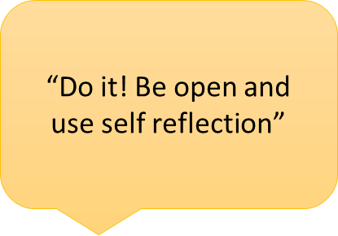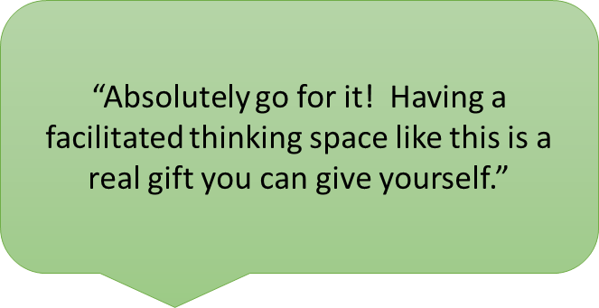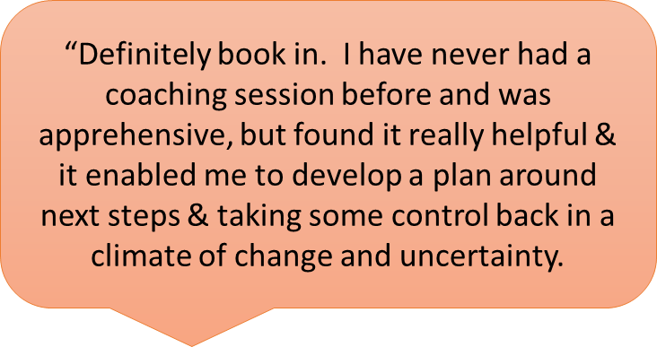

I would love some coaching! Where do I go next?
If you’re ready to find a coach now, you can do so here by registering as a coachee on the ICS Coaching & Mentoring Hub & creating a profile. As part of this profile, you will identify areas you might like to explore in some coaching and the system will then automatically find coaches that could match your needs. You can choose who you would like to approach and then make contact with them directly. The Hub can be accessed at https://hwics.onpld.com

I am a qualified coach – how do I get involved?
Do you work in our ICS, hold a coaching qualification and are keen to be part of our Coacing & Mentoring Hub? We would love you to join our growing team of coaches on the Hub! You can find out more here, or visit https://hwics.onpld.com to register and complete your coaching profile now. Being part of our ICS team will also give you access to ongoing development, peer support & supervision opportunities.

Still got questions?
Find out more on the ICS Academy Exchange or via email at hwicb.icsacademy@nhs.net

