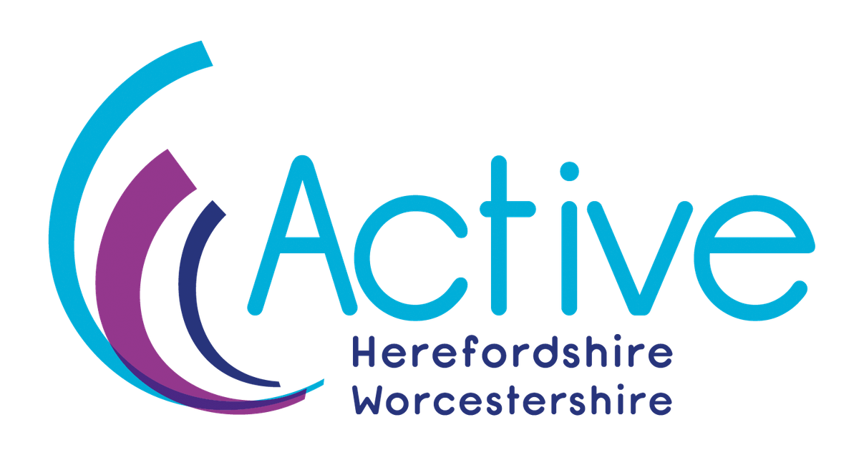

Community Development Lead
Apply online via our application form, you can download the application form via our website using the following link - https://www.activehw.co.uk/jobs/ CV’s will be accepted alongside a cover letter that clearly addresses each point in the personal specification, using specific examples where you have them.

About us
We are the strategic lead for sport and physical activity across Herefordshire and Worcestershire.

An independent charity committed to improving the lives of people across the two counties through the power of physical activity and sport.

As part of a national network of 42 Active Partnerships across England, we play a pivotal role in shaping how priority audiences and communities move more.

As a Sport England funded system partner, we interpret and localise national government strategies, Sport England's Uniting the Movement framework, and county public health, local authority, ICB strategies and national sporting governing bodies, turning policy into meaningful local action.

Find out more by watching this short animation video https://youtu.be/uruLHygC5Lo

CEO Introduction

Dear Candidate

Thank you for taking the time to find out more about this role.

Active Herefordshire and Worcestershire exist to make it easier for everyone across our two counties to be active. That means focusing our energy on the people and places where the barriers are greatest — children and young people from lower-income households, older adults, people living with long term health conditions, and communities where inactivity is highest.

We do not do this work on our own. We work alongside local authorities, the NHS, Integrated Care Board, Public Health, voluntary organisations and community networks to create the conditions where more people can move more, more often. We also work with national partners especially Sport England aligning closely to the Uniting the Movement Strategy.

This is an exciting moment for Active Herefordshire and Worcestershire. We are shortly launching a new organisational strategy, building on the strong foundations we have already laid and sets a clear direction for the years ahead. The relationships we have built across Herefordshire and Worcestershire, with statutory partners, the voluntary and community sector and local providers, give us a genuinely strong platform to work from.

CEO Introduction
To get there, we need the right people around us. We are a small, motivated and supportive team who care about the work and about each other. We invest in our people, we learn together and we try to make Active Herefordshire and Worcestershire a great place to work.


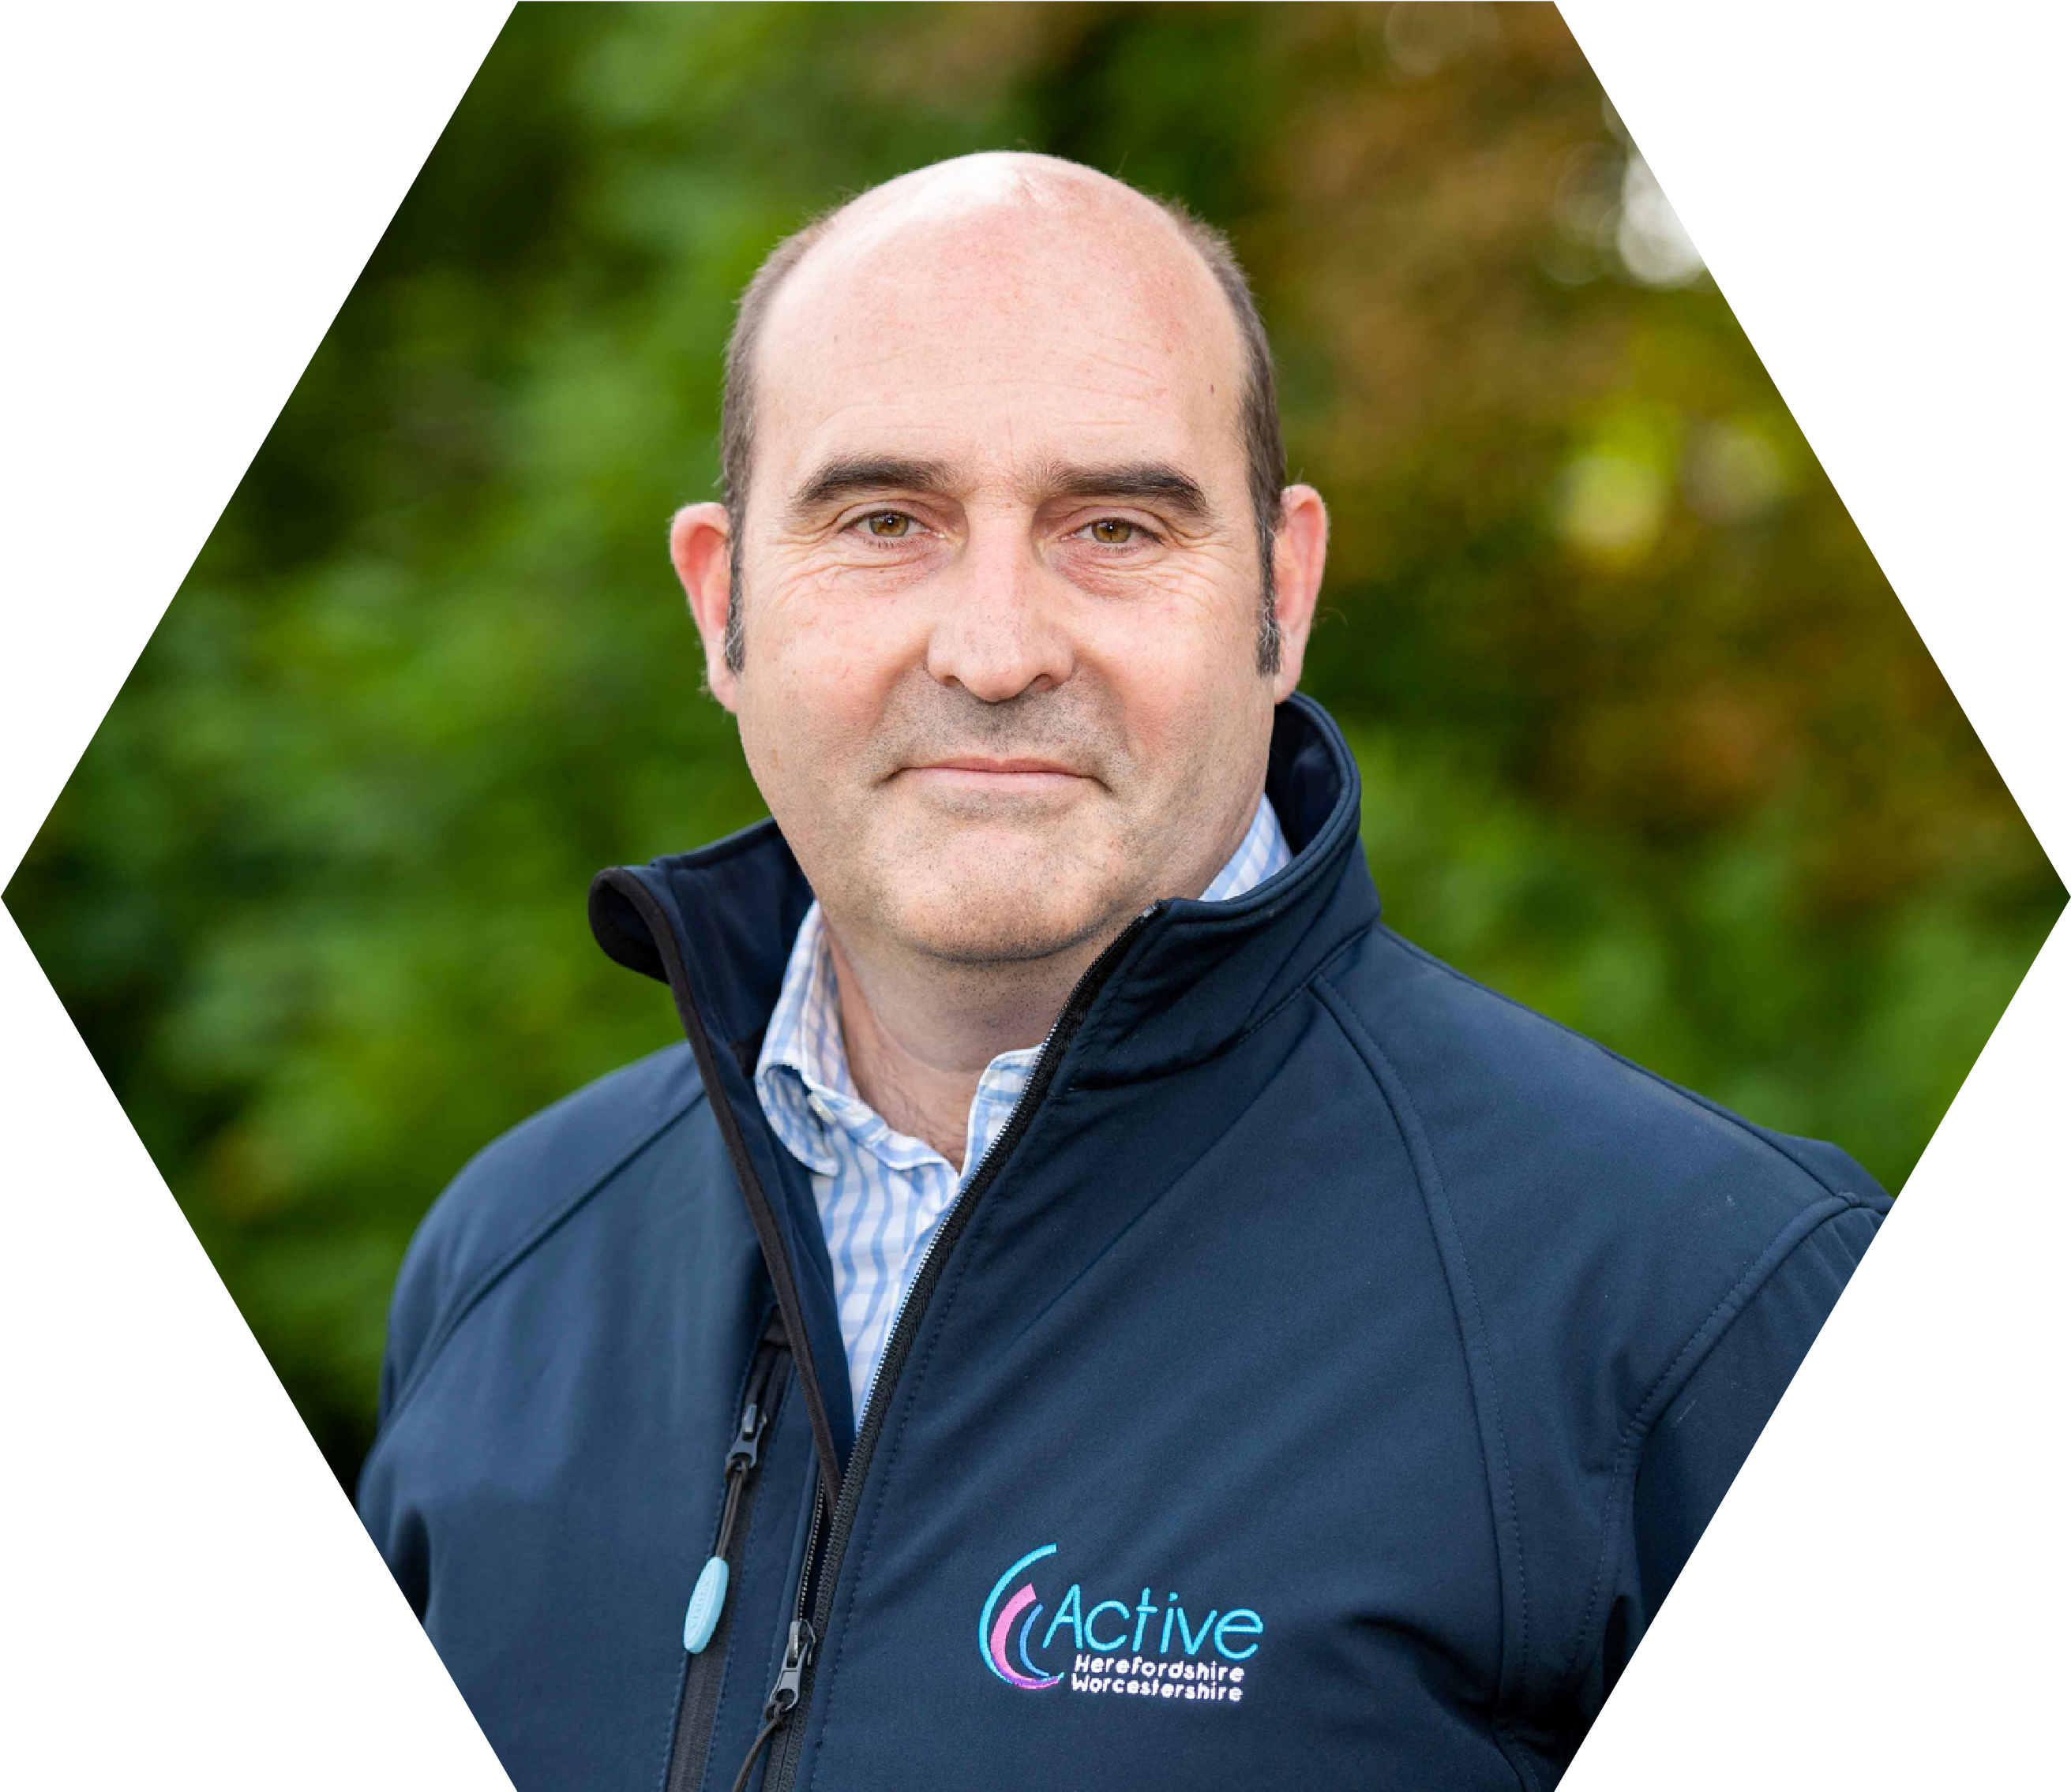
We are keen to attract people with diverse backgrounds, perspectives and experiences — both from outside the organisation and by developing the talent we already have.

If you are looking for a role where you can make a difference and improve people’s lives, where you will be part of a team that genuinely supports one another, and where you can help shape an organisation at an important point in its journey — this could be the right opportunity for you.

We look forward to hearing from you.

Yours sincerely

Steve Brewster

Chief Executive Officer
Active Herefordshire and Worcestershire

Our Vision

Our organisational vision is: “Everyone Active for Life”

Our Mission

With our know how, we can get the communities we serve moving and active, improving health and wellbeing, transforming lives and creating lasting change.

Our Values

We are finalising our 2026 – 2029 organisational strategy, as part of this we are reviewing our organisational values.

Our existing values are:

Inclusive - We are committed to transparency and equality. We champion diversity.
Energy - We are a vibrant organisation that makes sport and physical activity happen, with a hardworking and enthusiastic approach.
Quality - We are dedicated to delivering to high standards and are motivated to achieve the best results with the greatest impact.
Teamwork - We work with integrity and in unity, complementing one another to establish and realise shared goals.
Respect - We consider, understand and value other's opinions and circumstances.

Job Information

Post: Community Development Lead
Salary: £32750 – £34950
Hours: Full Time
Contract: Fixed until end of March 2028, with the possible extension subject to external funding.
Reporting to: Deputy CEO
Office Location: Based out of the University of Worcester, Hines Building, Henwick Grove, Worcester, WR2 6AJ. There is an expectation to be present in the identified priority communities.
Agile working policy in place subject to the needs of the business.

About the Role
Do you thrive connecting people?

Are you someone who cares about the communities around them and wants to do work that makes a genuine difference to people's lives by building relationships, spotting opportunities, and bringing the right people together?

If so, we want to hear from you, you do not need to be an expert in sport or physical activity. We are looking for is someone who has a genuine interest and commitment to understand communities, build trusting relationships, connecting and supporting the right organisations, networks and individuals.

This is not a delivery role. You will not be running sessions or managing facilities. The role is to facilitate, convene and connect, working alongside communities and partners so that they shape what happens in their place.

What this role is about

We know the massive benefits that moving more has on individuals physical and mental wellbeing and health. For many people, the idea of moving more and being active feels distant. There are other pressing priorities getting in the way, for example cost, health, transport, caring responsibilities, access to areas to be active.

The role will focus on priority areas (initially Leominster and Redditch), where the barriers faced are greatest, helping to understand and address the barriers to enable people to move more. These priority areas will include individuals and families living on low incomes, individuals living with a disability and/or long-term health conditions and culturally diverse communities.

The role is to work collaboratively, alongside those living in the community as well as organisations and networks that are already trusted and working in these priority areas, in order to provide a coordinated approach to understand the barriers and support the local communities to identify solutions to move more.

Active Herefordshire & Worcestershire has been successful in attracting investment from Sport England's Place Universal Offer, to develop a strong understanding of community needs and collaborate with partners to support priority places, promoting community-led, locally driven approaches across Herefordshire and Worcestershire.

The Community Development Lead will be the catalyst for implementing the action plan that is in place covering 8 areas of support.

Place Universal Offer

- Support to build on progress
- Access to facilitators
- Support for evaluation and learning
- Leadership support
- Place based test and learn approaches
- Capacity and capability building
- Specialist support and resources
- Networking

The journey we support:

When we think about moving more, physical activity and playing sport, we see this as a continuum, this role focusing on moving more to then being physically active:

- Moving more — getting people who are currently inactive to simply move a little more in their daily lives. For example, a walk to the shops, a community exercise class.
- Being physically active — supporting people to build regular activity into their lives in a way that feels sustainable and enjoyable for them, whatever that looks like.
- Playing sport — for those who want it, helping create pathways into organised sport, clubs and competitive activity.

How we learn

Alongside meeting community needs, you will capture and share what you learn, helping us encourage similar community-based approaches across both counties.

You will work with specialist data consultants to broaden our understanding of local insight.

We are part of an England network of 42 Active Partnerships, giving us access to wider data and learning from across England. This means we can see what is working elsewhere and apply it in a way that makes sense locally.

Find out more by the community focused approach watch this short animation video - https://www.youtube.com/watch?v=1wnIf7we5fI

You will be part of committed team working at Active Herefordshire and Worcestershire.

Why work for us?

Active Herefordshire and Worcestershire is committed to being diverse and inclusive, demonstrated through pro-actively delivering our Diversity and Inclusion Action Plan.

Through our People Plan, we are committed to being a great place to work – attracting diverse people whilst retaining a skilled workforce in an environment where people can thrive and grow.

As well as the opportunity to develop your skills in a rewarding and challenging role, we offer:

- Agile working – Combination of working from home and office-based work e.g. Mon – Weds in office, Thurs-Fri at home.
- Annual leave – 25 days, plus 2 discretionary days for Birthday and extra day at Christmas, 8 bank holidays
- Opportunities for staff CPD training, individual or team, coaching, external conferences and meetings, internal staff briefings and monthly staff meetings
- Family and people friendly policies and procedures
- Two team staff celebration days
- Enhanced pension (5% employer contribution) - Staff are enrolled
- into the pension scheme after 3 months
- Enhanced sick pay
- Enhance maternity pay
- Free parking – A paid annual permit for University of Worcester
- Flexible Working
- campus car parks
- Provision of hot drinks in the office
- Health & wellbeing initiatives, including:

1. Monthly health and wellbeing salary contribution
2. Weekly paid half an hour wellbeing session
3. Access to Occupational health support
4. Access to Mental Health First Aiders
5. University of Worcester Fitness gym (Riverside Fitness) membership discount

Job Description

This role has two main priorities:

- Working closely with a small number of priority communities and neighbourhoods (initially Leominster and Redditch).
- Using what we learn from that work to encourage more community-focused approaches across both counties

- Working in priority communities and neighbourhoods

- Get to know your priority communities well. Use data, local insight, and conversations with community champions, partners, stakeholders and networks to build our understanding of the barriers local people face.
- Build trusted, lasting relationships with local decision makers including community champions, partners, networks, providers and delivery organisations.
- Bring people together. Connect local decision makers, stakeholders, partners, networks and community champions, help them see how physical activity can improve people's lives, while avoiding duplication of effort.
- Bring statutory bodies, providers, community representatives and voluntary and community sector partners together to identify the inequalities stopping people from being active and work together to shape solutions.

- Sharing what we learn to encourage more community-based working.

- Help deliver Active HW's 3-year Place Universal Offer action plan.
- Find ways to encourage and support more community and neighbourhood approaches across both counties — for example, through better communication, shared learning and networking opportunities.
- Manage your allocated budget.
- Work closely with the wider Active HW team to support place-based work.
- Help us continuously learn from and evaluate the Place Universal Offer.

Personal Specification - Essential

Your application will be assessed against these criteria. If you think you might have most of the essential aspects but are not 100% sure, please do still apply and let us decide:

Community connection and understanding
You have experience working with, or alongside, specific communities, not just delivering services to them. You understand the real-life barriers that stop individuals and communities from being active.

Relationship building and partnership working
You can build genuine, lasting relationships with a wide range of people and organisations, including community groups, statutory partners, health services, voluntary organisations and local networks.

Connecting people, resources and ideas
You can spot opportunities to join things up. You're comfortable working across organisations, sectors and communities, and you're good at helping different people find common ground and work towards a shared goal.

Communication
You can communicate clearly and credibly with very different audiences, from a resident in a community hall to a senior commissioner in a formal meeting. You listen to understand, not just to respond. You believe in the importance of community voice and co-production.

Delivery and self-management
You manage your time well, follow through on commitments and can balance a varied workload. You are comfortable with some uncertainty and can adapt.

Equity and inclusion
You think about how to make your work more accessible and inclusive. You understand inclusive practice and have some experience of building equity into how you plan, deliver or evaluate your work.
Decision making
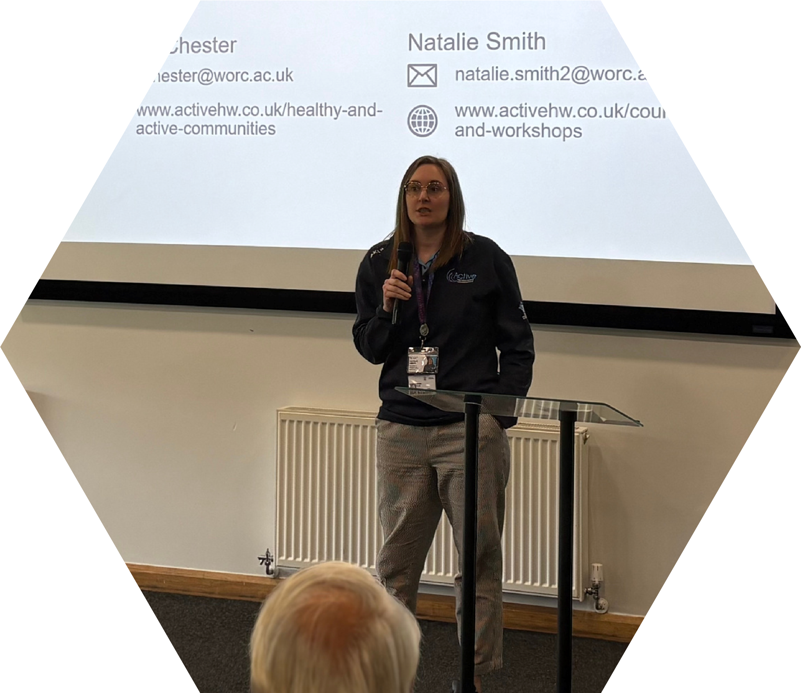
You are confident making informed decisions on your own and you know when to ask for support or escalate something.

Access to transport
You have access to a car or other suitable transport, a driving licence, and business insurance. You are willing to travel across Herefordshire and Worcestershire, and to work occasional evenings or weekends with reasonable notice.

Personal development
You are committed to continuous learning and improvement, and you reflect on your own work and the work of others, to keep getting better at what you do.

Personal Specification- Desirable

Your application will be assessed against these criteria. If you think you might have most of the essential aspects but are not 100% sure, please do still apply and let us decide:

Understanding the barriers facing individuals and communities
You have some awareness of the challenges that stop individuals and communities moving from inactivity towards regular movement and physical activity.

Knowledge of local infrastructure
You have some familiarity with how statutory organisations (such as local authorities) and voluntary and community organisations, networks and individuals can work together to make a difference.

Behaviour change awareness
You have some understanding of the principles behind behaviour change.

Budget management
You have some experience of managing or monitoring a budget.

Awareness of Active Partnerships:
You have some knowledge of how Active Partnerships operate, or of Sport England's Uniting the Movement strategy.

General Information
The job description is representative of the role as it is at present, constituted, and is therefore subject to review and updating from time to time.

It is Active Herefordshire and Worcestershire’s policy to consult the employee and to aim to reach agreement on amendments, but nevertheless the right to make any reasonable changes is reserved.

If you think you might have most of the essential aspects within the person specification but are not 100% sure, please do still apply and let us decide.

We know that certain groups rule themselves out of opportunities assuming others will be more successful, but please don’t be that person.

We want applications from the widest cross-section of the community.

Using AI

We use AI tools at Active Herefordshire and Worcestershire to improve our ways of working, how we communicate, plan and learn.

For your application we want to hear from the authentic you. If you use to AI, use it to check your spelling, grammar and clarity. But not to write your application. We are often aware when an application is AI-generated and that may work against you. We want to hear about the real you and why you want to apply for this role.

Other Details

Equality Statement:
Active Herefordshire and Worcestershire is committed to being an equal opportunities employer and welcomes applications from all members of the community.

Privacy Statement:
Active Herefordshire and Worcestershire takes your privacy very seriously. More information on how we collect, manage, process and store your data can be found in our privacy policy
Link: https://www.activehw.co.uk/privacy-policy.

Next steps:

Closing date: Sunday 12th July 2026 by 23:59PM

Interviews for shortlisted candidates will take place on Tuesday 21 July 2026

References will be carried out for the successful candidate.

Apply online via our application form, you can download the application form via our website using the following link - https://www.activehw.co.uk/jobs/ CV’s will be accepted alongside a cover letter that clearly addresses each point in the personal specification, using specific examples where you have them.

Learn more:

For an informal discussion and to learn more about the role, please call Simon Thomas, DCEO - telephone number: 07717 422184 Email: simon.thomas@worc.ac.uk.

"STEPHENS, Kate (NHS HEREFORDSHIRE AND WORCESTERSHIRE ICB - 18C)" <kate.stephens12@nhs.net>
"ROBERTS, Vanessa (NHS HEREFORDSHIRE AND WORCESTERSHIRE ICB - 18C)" <vanessaroberts1@nhs.net>

