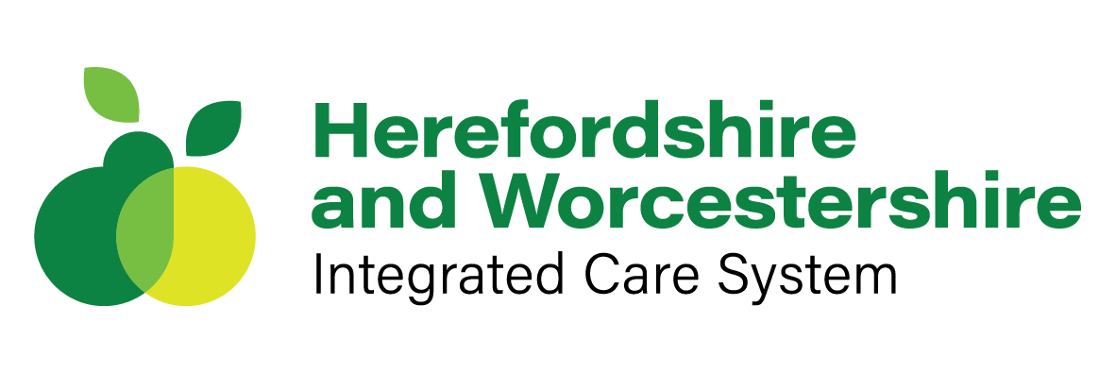


My Health & Wellbeing Passport
Helping you manage your own wellbeing
while looking after others




With thanks and acknowledgement to Worcestershire Acute Hospitals NHS Trust for their development of the ‘My Health & Wellbeing Passport’ and for agreed permission of use.

Contents

My Personal Details 4

Confidentiality Agreement 4

My Personal Circumstances 5

Disability/Long Term Health Condition(s) 6

Reasonable Adjustments 7

My Personal Wellbeing Action Plan 8

My Caring Responsibilities 9

Work-Life Balance and Flexible Working 10

Financial Wellbeing 11

Additional Information 12

Record of Reviews 13

Further Support 14

Introduction

The purpose of your ‘My Health & Wellbeing Passport’ is to support you to bring your whole self to work. It is recognised that there are many factors that make up every member of staff and that each of us have different individual needs.

[Employer Name] would like to support all staff to feel confident to bring their whole self to work and know that they will be supported in all aspects of their health and wellbeing, whether this relates to their working life or personal life.

This Health and Wellbeing Passport is intended to help you to reflect your individual needs and support you to undertake your role effectively within a supportive environment where your diversity is celebrated. It can be used by any member of staff who feels that they need support at work in relation to their wellbeing. For example, a member of staff who has a disability or long-term condition, someone who has caring responsibilities outside of work, parents with children or those who observe religious festivals or celebrations such as Ramadan.

You can ask your line manager to support you to complete your Health & Wellbeing Passport or your manager may suggest this to you if they feel it could benefit your health and wellbeing. You can also transport this passport with you if you move to a different role within the Trust or if you have a new line manager. This passport should be reviewed regularly with your line manager to ensure that the support in place continues to meet your needs. The review should be at least annually but may be more often than this if you need more regular support or if your needs change. Any changes should be recorded in Section 11.

There is no requirement to complete all sections of the Health & Wellbeing Passport as you may find that some sections are not relevant to you.

This is your Health & Wellbeing Passport and should be something that you find helpful and that makes a positive difference to your health and wellbeing. If at any time you feel that further support is required, please speak to your line manager who will review your passport jointly with you. You can also find a list of other contacts within this passport that you may find helpful.

If you need any help and support with completing your Health & Wellbeing Passport, please contact [insert contact details].

My Personal Details

Name
Job Title
Employee Number
Team/Department
Directorate
Name of Line Manager

Confidentiality Agreement

The information held in this Health & Wellbeing Passport is confidential and will not be shared with any other party without your written consent. You are the owner of your Health & Wellbeing Passport and given the confidential nature, you should hold a copy of the passport personally and can share with your line manager as needed. You should agree with your line manager who, if anyone, should have access to your passport and where it should be stored.

Employee’s Signature:
Date:
Line Manager’s Signature:
Date:

My Personal Circumstances

Please use this space to give a description of your personal circumstances. This can include anything that has an impact on your life inside or outside of work. For example, your disability, long-term health condition, menopause, religion, gender reassignment, caring or childcare commitments.

Please use this space to describe how your personal circumstances may impact your health and wellbeing at work. You may wish to include details here of who should be contacted if you become unwell at work, for example if you suffer with migraines or epilepsy and suddenly become unwell at work and may not be able to make your way home without additional support.

Disability/Long-term Health Condition(s)

What is the nature of your disability, neurodiversity or long-term health condition? This could include the nature of any health issues/when you were diagnosed/day-to-day symptoms/what is a good day and a bad day/how you manage them/if your condition fluctuates how often are episodes/what are triggers/ any existing aids or equipment/ how your health impacts on your mood/ do you experience pain/any side effects of treatments

Is your disability/health condition long-term or expected to improve/deteriorate?

Are there any Occupational Health/Access to Work Recommendations? (it may be useful to refer to any appropriate reports)

What support/reasonable adjustments would benefit you at work? Would you like to discuss possible support options? e.g. flexible hours, reduced hours, equipment, change of duties?

Reasonable Adjustments

Reasonable adjustments are changes made by [employer name] to remove or reduce a disadvantage related to your disability. This might include making changes to the workplace, finding a different way to do something, changing your working arrangements or providing you with equipment, services or support. Reasonable adjustments are specific to you as an individual and can cover any area of work.

Please use this space to record any reasonable adjustments that you have discussed and agreed with your line manager (what is practical, reasonable and likely to be effective). Detail clearly each adjustment and who will do what.

If you are unsure about how to take an action forward, detail who will look into it and by when.

If your line manager has not been able to agree an adjustment, they should provide you with information about the reason this cannot be supported and this should be documented below.

Suggested  Reasonable Adjustment | Responsibility  (who will do what) | Date Agreed

NB: if flexible working is agreed as a reasonable adjustment, the flexible working application process must also be completed. You can access the flexible working policy and toolkit and additional resources here [insert link].

What information, if any, needs to be shared with your team to support the agreed adjustments to
be implemented? You should agree what information will be shared and who it will be shared with.

My Personal Wellbeing Action Plan

How do you feel when you are at your best?

How do you feel when your wellbeing is drained?

What are the warning signs for a drop in your wellbeing? What might other people notice?

What things do you do to maintain/enhance your health and wellbeing?

What additional support would be helpful to maintain/enhance your health and wellbeing?

[insert information about wellbeing conversations if relevant]

My Caring Responsibilities

Please use this space to give a brief description of your caring responsibilities. For example, who you are a carer for? If appropriate, how long have you been a carer? Do you currently have any additional support in your caring role? How do you expect your caring role (and its impact) could change in the future?

What impact do your caring responsibilities have on you at work e.g. time off for appointments, emergency time off, carer telephone time at work?

Is there any help and support that you need to help you to continue your caring and work role, for example flexible working, hybrid working, rolling carer days?

Work-Life Balance & Flexible Working

Please use this space to identify any relevant information regarding your work-life balance and your commitments outside of work that may have an impact on your working time/pattern

Do you currently have any flexible working arrangement in place? If so, please set out the nature of your current flexible working arrangement and whether this fully supports your needs.

Is there any help and support you need to help you manage your work-life balance or flexible working needs?

If you need to make a formal flexible working request or need more information about flexible working following your discussion, you can access the policy and toolkit and additional resources here [insert link].

Financial Wellbeing

Financial Wellbeing is an important consideration when thinking about your overall health and wellbeing and it is important to address this alongside your physical, emotional and mental wellbeing. Your manager or the Trust cannot provide you with financial advice but they can give you guidance about services that can provide you with impartial advice on money and support you if money worries are affecting your health and wellbeing.

Please use this space to describe how you feel about your current financial wellbeing? It might help to think about financial wellbeing as feeling secure and in control of your finances. This can include being able to make the most of your money day-to-day whilst being able to deal with the unexpected and plan for the future.

Is there anything that you feel will impact your financial wellbeing in the next 12 months?

Do money worries have an impact on your wellbeing or your ability to do your job?

Is there any help and support you need to help you manage your financial wellbeing?

You can access more information here [insert link].

10. Additional Information

Please use this space to share any other information that may be relevant to your health and wellbeing that hasn’t been covered in the previous sections.


11. Record of Reviews

Date of Review | Summary of Changes Made | Employee Signature | Line Manager Signature

12. Further Support

Insert organisational health and wellbeing support and links here:

You might include:

- Staff Health & Wellbeing Guardian
- Wellbeing Conversation Facilitators
- Staff Networks
- Counselling Service
- Psychological Wellbeing Support
- Occupational Health
- Chaplains
- Human Resources
- Trade Union Representatives
- Freedom to Speak up Guardian

